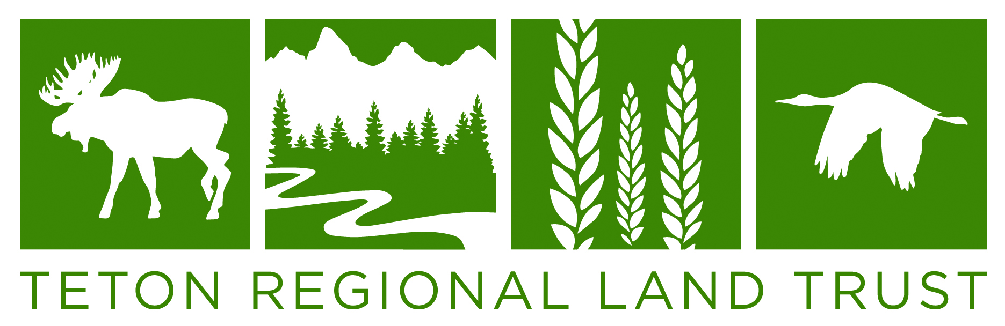
2024
Teton Regional Land Trust
Michael B. Whitfield Scholarship Guidelines

Background: The Teton Regional Land Trust created this scholarship in honor of Michael B. Whitfield who helped found the organization in 1990 and served as its Executive Director for 18 years. Michael’s passion for and commitment to land conservation in eastern Idaho has been instrumental in the preservation of key landscapes in the Greater Yellowstone Ecosystem.

Award: $2,000

Eligibility: Students must live in the Teton Regional Land Trust service area. Counties include Bonneville, Clark, Fremont, Jefferson, Madison, and Teton, Idaho, as well as Alta, Wyoming. Candidates must show an intention to pursue a major course of study in college or vocational school in the environmental sciences, biology, ecology, environmental planning or policy, agriculture, or a related field. Applications must be received or postmarked by March 8th 2024. Scholarship funds are open to graduating seniors. The award must be used for undergraduate education.

Application: In an essay of 600–2,000 words, please write about your career aspirations, goals, and what you hope to achieve with the scholarship funds. It would be helpful for candidates to write about their philosophy regarding environmental issues; including their perspective on natural resource conservation on local, regional, and/or national levels. How do you see yourself and your generation affecting environmental matters in the future?

Attachments: Transcript
References – minimum of two, non-family preferred
Essay and any other information the candidate would like to include

Mail applications to: Mandy Crane, Teton Regional Land Trust, P.O. Box 247, Driggs, ID 83422
Or e-mail applications to: mandy@tetonlandtrust.org

The scholarship award will be paid directly to the recipient’s school of choice. The Financial Aid contact number and student ID will be required.

***Applications must be received or postmarked by March 8th 2024***

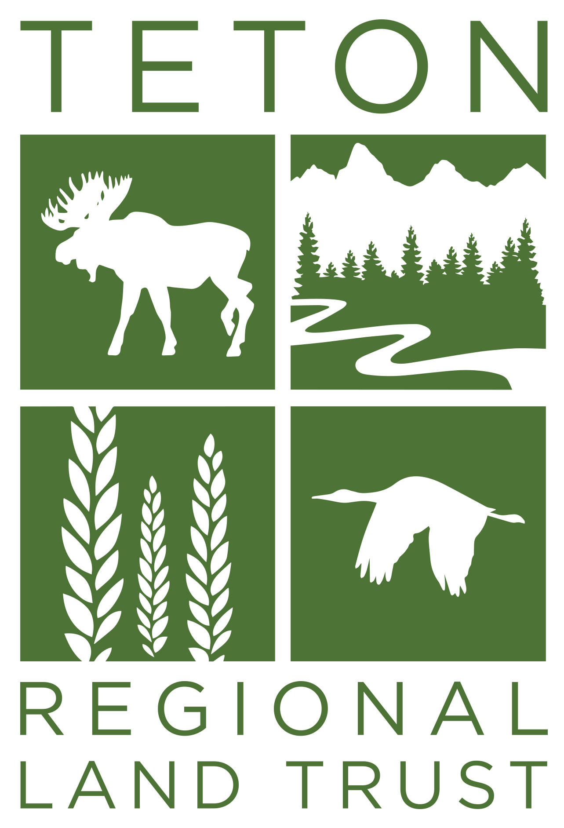
Teton Regional Land Trust
Michael B Whitfield Scholarship Application

Student and Contact Information

Name:_____________________________________________________________________________

Address:___________________________________________________________________________

__________________________________________________________________________________

Phone:_____________________________________ Email:__________________________________

Parent or Guardian

Name:_____________________________________________________________________________

Address:___________________________________________________________________________

__________________________________________________________________________________

Phone:_____________________________________ Email:__________________________________

Current High School:_________________________________________________________________

Current GPA: _____

College / University / School Applied to:

- ____________________________________________________________________________

- ____________________________________________________________________________

- ____________________________________________________________________________

Please attach:
- High school transcript
- References
- Essay

Teton Regional Land Trust l PO Box 247 l Driggs, ID 83422 l www.tetonlandtrust.org

