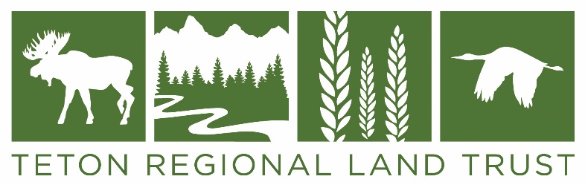
Greater Yellowstone Crane Festival Poster Contest Guidelines and Application:

- Only original artwork, not photography, will be considered. Artists are encouraged to sign their artwork.

- Deadline: 5pm Monday, April 15, 2024; the winner will be notified by May 1, 2024.

- All entries must be finished and suitable for reproduction.

- Please understand that we will need to add “Greater Yellowstone Crane Festival, September 18-21, 2024”, “Teton Valley, Idaho”, and the Land Trust’s logo to your artwork if it is made into the official festival poster.

- The finished poster will be printed with a bottom border which will include the event logo and the sponsor logos. The printed posters will be 12” x 18” or larger.

- Posters will be distributed to promote the event and used in print and digital ads in Teton Valley, Jackson, Idaho Falls, Rexburg, Pocatello, Island Park, and possibly more.

- The winning design will also be used on merchandise such as t-shirts, hats, totes, etc.

- The winning artist will be awarded $250 and will receive a framed copy of the poster and several of the souvenir items produced with his or her artwork.

- We would love for all artists to donate their original artwork to the Land Trust to be used in an art auction to raise funds to support the Greater Yellowstone Sandhill Crane Initiative.

- We encourage the winning artist to promote their artwork during the Crane Festival.

- You may submit a high-resolution photo of your artwork via email (preferred method) or mail. If you want to drop it off in person, please contact Mandy for an appointment mandy@tetonlandtrust.org.
USPS mailing address: Teton Regional Land Trust, PO Box 247, Driggs, ID 83422
Physical address: Teton Regional Land Trust, 1520 South 500 West, Driggs, ID 83422

- Application below must be submitted with artwork.

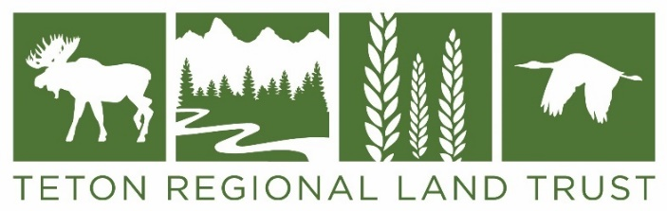

Greater Yellowstone Crane Festival Poster Contest Application

Applicant Information
Full Name: |  |  |  | Date:

Address:
 | Mailing Address | Apartment/Unit #

 | City | State | ZIP Code

Phone: |  | Email

Artwork Information

Title of Artwork:

Medium used:
Description of artwork:
Do you want to donate your artwork to TRLT to raise funds for the Greater Yellowstone Sandhill Crane Initiative? |  |  |  |  |  | YES  ☐ | NO  ☐

If yes, what is the approximate value of the artwork?

Signature
If your artwork is chosen for the poster, and you did not sign your artwork, we will need to digitally add your signature. Please provide your official signature below.

Signature:

