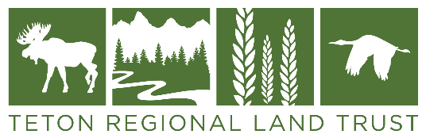
DECLARATION OF FUTURE INTENT
Thank you for your intention to include Teton Regional Land Trust in your estate plan. We ask that you complete this form with as much detail as you are willing to share. Any information about your gift will remain confidential.

My/Our Information:
Full Name (print): ________________________________________________________________
Address: ___________________________ City: _______________ State: _______ Zip Code: ________
Phone Number: ___________________ Email Address: ______________________________________

Gift Information:
I/We have provided a gift to the Teton Regional Land Trust as set forth in my/our:
Will or Trust Charitable Gift Annuity Life Insurance Policy
Charitable Remainder Unitrust Retirement Plan or Beneficiary Designation
(401(k), 403(B), IRA, Keogh, Brokerage Account)
Other Asset(s) (please describe):____________________________________________________________
The Teton Regional Land Trust is a contingent beneficiary of the indicated asset above.
(Please Explain):____________________________________________________________________________

The current estimated value of my/our gift is $____________________________. My/Our gift is ___________% of the asset indicated above. If a percentage is given, what is the current estimated value of the percent in today’s dollars $______________________.

Gift Purpose:
Gift Agreement/Letter - I/We have signed a Gift Letter or Agreement with Teton Regional Land Trust stating the designation or purpose for this gift.
I/We have not signed a Gift Letter or Agreement. It is my/our intention that the Teton Regional Land Trust use this future gift to best support its mission, without any restrictions.

Recognition:
Donors who provide a planned gift to benefit the Teton Regional Land Trust will be acknowledged as both Lifetime Members and as a member of the Legacy Circle.
I/we prefer no public recognition
Please list my/our name(s) as follows: _________________________________________________

Estate Contact Information:
Although optional, the following information is very helpful:
Executor, Trustee (if your gift is through a Will, Trust):
Name (print): ________________________________________________________________________
Address: ___________________________ City: _______________ State: _______ Zip Code: ________
Phone Number: ___________________ Email Address: ______________________________________

Additional Contact/Relationship you may want us to know (family, attorney, etc.)
Name (print): _____________________________ Relation:__________________________________
Address: ___________________________ City: _______________ State: _______ Zip Code: ________
Phone Number: ___________________ Email Address: ______________________________________

The Teton Regional Land Trust understands that the size of my/our future gift may change.
Signature: _______________________________________________ Date: _______________________

Please return this form to:
Teton Regional Land Trust | PO Box 247, Driggs, Idaho, 83422 | email: jeske@tetonlandtrust.org | phone: (208) 354-8939

