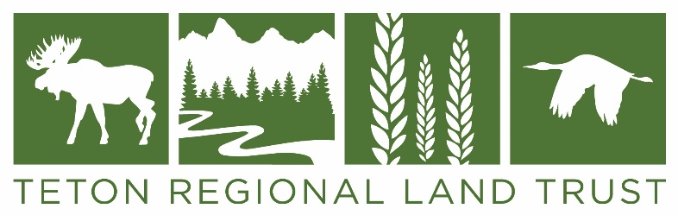
Greater Yellowstone Crane Festival Poster Design Contest Guidelines:

- Only original artwork will be considered. Artists are encouraged to sign their artwork and provide the title of their work.

- Deadline: 5pm Monday, April 20, 2020
The winner will be notified no later than May 8, 2020.

- All entries must be finished and suitable for reproduction.

- Please include “Greater Yellowstone Crane Festival” and “September 14-19, 2020” and “Teton Valley Idaho” in your design or understand that we will need to add this information to your artwork when it is made into the official festival poster.

- The finished poster will be printed with a bottom border which will include the event logo and the sponsor logos. The printed posters will be 12” x 18” or larger.

- The winning design may also be used on merchandise such as t-shirts, hats, totes, etc.

- The winning artist will be awarded $250 and will receive a framed copy of the poster and one of each of the souvenir items produced with his or her artwork.

- The original art can be donated to support crane conservation or returned to the artist.

- All artists who submit poster designs are also invited to participate in the Teton Arts Crane Festival Art Show. This is a member show so if you aren’t a member, you will need to join. If you are interested, email kate@tetonlandtrust.org for more information.

- When we notify artists about the winning artwork, we will remind artists about the art show and ask if you would like to have your artwork returned or if you would like to donate it to support crane conservation.

- You many submit your artwork in person or by mail to:
Teton Regional Land Trust, PO Box 247/1520 South 500 West, Driggs, ID 83422
Please include your email address and a phone number, thank you.

