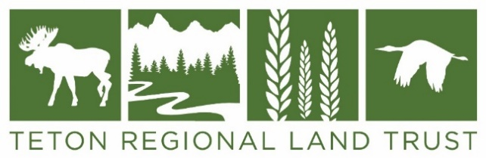

For More Information: Date
Kate Salomon February 19, 2020 (208) 354-8939 kate@tetonlandtrust.org

3rd Annual Greater Yellowstone Crane Festival Poster Design Contest
The Greater Yellowstone Crane Festival is held to celebrate the annual migration of Sandhill Cranes through Teton Valley. This year’s festival will be on September 14-19. Teton Regional Land Trust, on behalf of the festival, is seeking area artists to submit original poster designs for the annual poster design contest. The winning design will be the official poster for the 3rd annual Crane Festival and will be used on advertising, banners, and merchandise.
The weeklong event is held throughout Teton Valley and ends at the Driggs City Center Plaza on Saturday, September 19th with a community celebration, which includes nature-themed arts and crafts for kids, live music, crane inspired dances, poetry, art, food and drinks from local vendors, workshops, and presentations. The festival also includes the Teton Arts Crane Fest Art Show on exhibit in the Driggs City Center foyer with an artist’s reception on Thursday, September 17th. Artists can choose to donate a portion of their proceeds to directly benefit the work of the Teton Regional Land Trust in protecting Sandhill Cranes and their habitat in Teton Valley.
Entries for the 2020 Crane Festival Poster Contest are due on April 20, 2020. Please see the 2020 Poster Design Contest Guidelines for official rules and instructions on how to submit your artwork. All artists who enter the contest are invited to participate in the Crane Fest Art Show.
Teton Regional Land Trust is a 501(c) (3) whose mission is to conserve working farms and ranches, fish and wildlife habitat, and scenic open spaces in eastern Idaho for this and future generations. For more information, please call 208-354-8939 or visit our website at: www.tetonlandtrust.org

###

