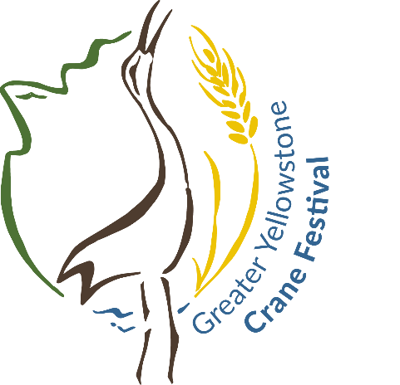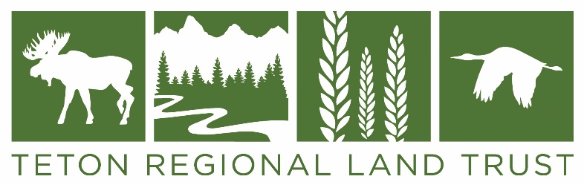

Greater Yellowstone Crane Festival Poster Design Contest Guidelines:

- Only original artwork will be considered. Artists are encouraged to sign their artwork.

- Deadline: 5pm Wednesday, May 1, 2019
The winner will be notified no later than June 1, 2019.

- All entries must be finished and suitable for reproduction.

- Please include “Greater Yellowstone Crane Festival” and “Saturday, September 21, 2019” and “Driggs, Idaho” in your design or understand that we will need to add this information to your artwork when it is made into the official festival poster. You may also include the Greater Yellowstone Crane Festival logo, but it is not required. You can request the logo by email: kate@tetonlandtrust.org

- The finished poster will be printed with a bottom border which will include the event logo and the sponsor logos. The printed posters will be 12” x 18” or larger.

- The winning design may also be used on merchandise such as t-shirts, hats, totes, etc.

- The winning artist will be awarded $250 and will receive a framed copy of the poster and one of each of the souvenir items produced with his or her artwork.

- The original art can be donated to support crane conservation or returned to the artist.

- All artists who submit poster designs are also invited to participate in the Crane Festival Art Show. If you are interested, email kate@tetonlandtrust.org for more information.

- You many submit your artwork in person or by mail to:
Teton Regional Land Trust, PO Box 247/1520 South 500 West, Driggs, ID 83422

